**1. Oracle Password**

Access to Oracle is your standard single-sign-on password. Oracle accounts have been established for each member registered for the class.

**2. Using Oracle SQL*Plus In CLCs**

You may be able to access SQL*Plus directly from programs on the computers in a few CLCs (the ones in the Comp Sci building are more likely to have it).

Where an Oracle program exists in a CLC, you access it via (the version may differ):

Start => Programs => Oracle - OraClient11g_home1_32bit => Application Development

=> SQL Plus

[A sample screen shot is shown below (again, the version may differ).]

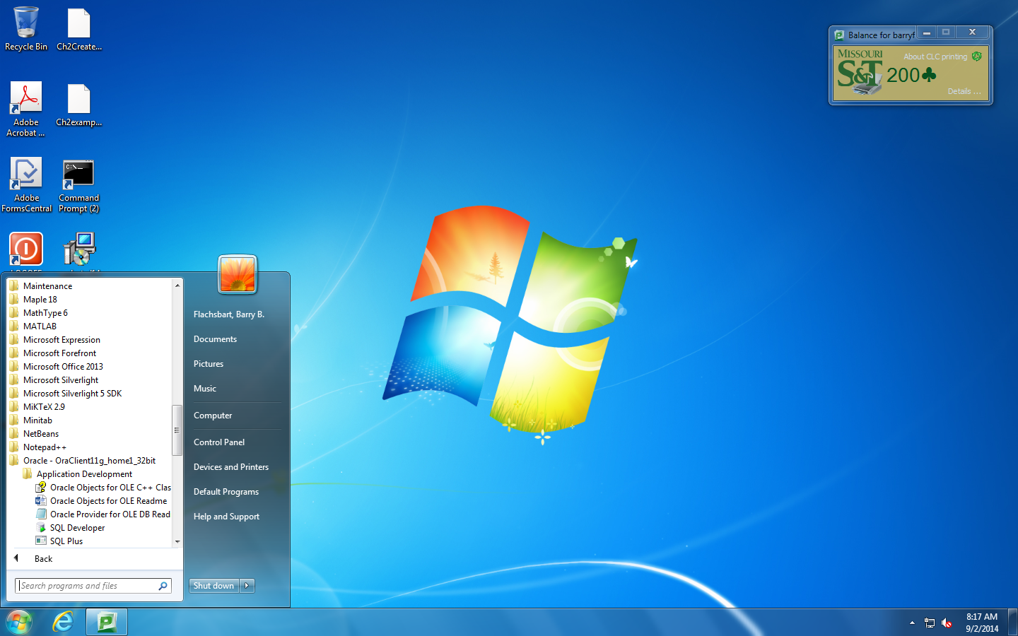

This will bring up one of the two login window similar to those shown below depending on which version of Oracle is installed: (note carefully where and how the host string, **scsp**, is entered**)**

Use your campus assigned userID and password, of course

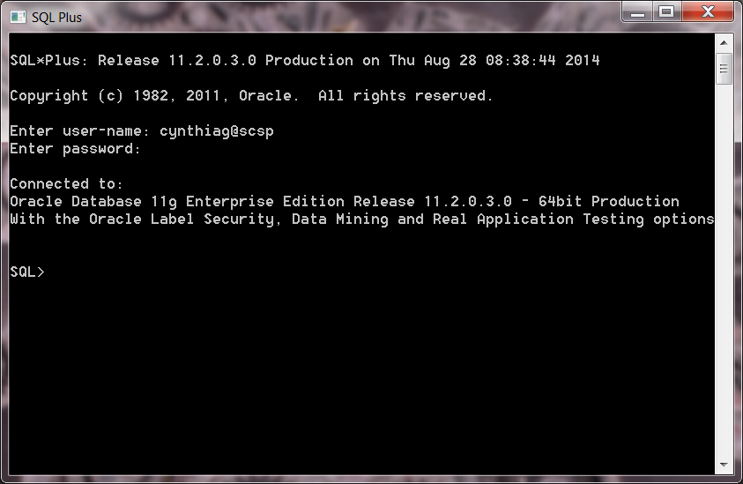

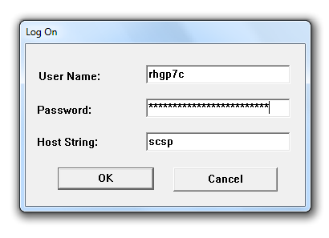

The next window is the SQL*Plus window, where you can enter SQL statements, after the SQL> prompt:

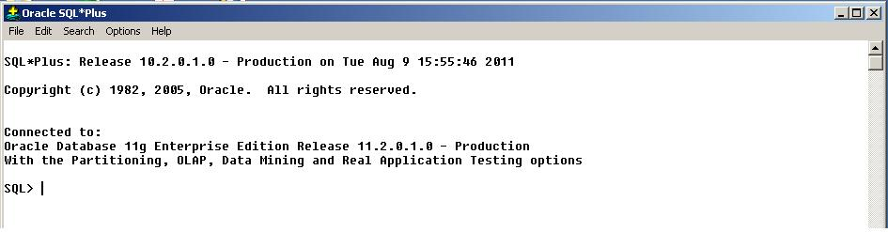

**Next, jump to 4**, below, but note the information about screen shots in 3.

**3. Using Oracle SQL*Plus From A Virtual Machine**

There is a capability for viewing Oracle (and other things) that uses a virtual machine.

You can load this onto your own computer -- it utilizes a web browser to get to Oracle on campus.

The capability is WMWare's Horizon Client.

It should also be available on several of the CLCs, so you can utilize it there to get to Oracle even though Oracle access might not be directly available in that CLC.

To obtain this capability, see HO 2a.

Once you have it, you can go to Oracle as described in 2 above.

Screen Shots* And Saving Things

When you are working from the virtual window, you can take screen shots, but you must paste them into documents that are opened on that virtual window. Further, you need to be sure to save these documents on your S drive (which you should be able to access from the virtual window) if you want to use them later.

Of course, if you now want to use those documents from a home or apartment off campus, you'll need a VPN connection to the campus to be able to access S. You also must use VPN prior to starting the Horizon Client, if off campus.

Information about VPN is available at:

<http://it.mst.edu/services/virtual-private-network/virtual-private-network-tutorials/>

Final Notes

If you are not connected to via the campus network, you will need to use VPN as well.

Don't forget to close the virtual window when you are finished.

Let me know of anything else that should be mentioned.

Thanks to Dr. Yu, to our IT support people, and to Riley Grennan for helping me get this to work.

**4. Verification**

Use Shift-PrintScreen to capture a screen shot or take a Snip* and then paste it into a Word document to verify that you have succeeded in getting to the SQL> prompt. Put your name on it and hand the document in at the next lecture. It will be worth 5 Quiz points.

Note: The Exit command takes you out of SQL*Plus: **exit;**

**5. Unusual Assignment**

This is an unusual assignment -- you MAY help each other.

**\* Note: In general, instead of using screen shots, you might find the SNIP feature (in Accessories) more convenient. You may want to drag this capability to the toolbar on your desktop to have it always available. In any case, you need to save the screen shot or SNIP on a document in order to turn it in.**